

# Emergency Ambulance Service

(An emergency helping App)

## Name: Mehbuba Jahan

## Roll: 1807120

# Objectives:

1. To help people in case of emergency and rescue situation.
2. To give immediate support/service to the patient
3. To provide proper possible care during transferring the patient to the hospital
4. To build a user friendly interface for smooth use

# Introduction:

Emergency Ambulance Service is a very helpful app which is designed to help the people in their need. In our country Bangladesh Government officially launched the 999 emergency helpline. But it works very slowly and therefor people get suffered. In this app I wanted to ensure that people have a better emergency service in their critical moments.

To develop this app Firebase Firestore database has been used. Cloud Firestore is a NoSQL document oriented database. Unlike a SQL database there are no tables or rows. Instead we store data in documents which are organized in collections. In cloud Firestrore, the unit of storage is the document. A document is a lightweight record that contains fields, which map to values. Each document is identified by a name and the names of documents within collection are unique. Each document contains a set of key value pairs. We can provide our own key, such as user IDs, or we can let Cloud Firestore create random IDs automatically. This document must be stored in collections. Data are simply assigned to a document within a collection.

For registration/sign up, Firebase Authentication has been used. Firebase Authentication is another feature of firebase provided by Google. This platform provides facilities of sign-up, sign-in, sign-out which is very necessary for this app.

# Implementation:

**Detailed Description:**

When someone opens the app he can see the splash screen having the app name and a relatable logo. Then comes the home page where there are two panel; Admin panel & User panel.

* The admin panel is for the owner of ambulance. Admin must register with all the required details such as location, availability status, contact number. Firebase Firestore is added to the project to store the registration information. Information of the admins was stored in separate documents under a collection (admin) in cloud firestore.
* Once registered he can simply log into his profile. For login purpose I used firebase Authentication. The login was based on e-mail and password.
* Admin’s profile will hold the information stored in the document under (admin) collection. He can update the details and it will be updated in his document as well. He also can update his e-mail address.
* Firebase Authenticated sign out method was also implemented. Once sign out admin will be redirect to the login page again.
* User panel doesn’t require any registration or login process so that people may get help immediately without any hassle which make this app user friendly. I used recycler view to list out all the details of firestore under admin collection. The information that the admin has given for registration purpose will be fetch from the firestore to the recycler view.
* I used a filer method in the adapter class based on the field- district and sub district. The searching method is case insensitive so that user can easily search ambulance by their current district or sub district.
* He can quick observe which ambulance is fit for his current location and can select it by pressing a button underlying. This button will redirect him to the next page where I implemented a calling method. For this I had set a calling permission in Manifest file. User can direct call through the app. He also can see the service terms and payment system from a popup window.

**Flow chart:**

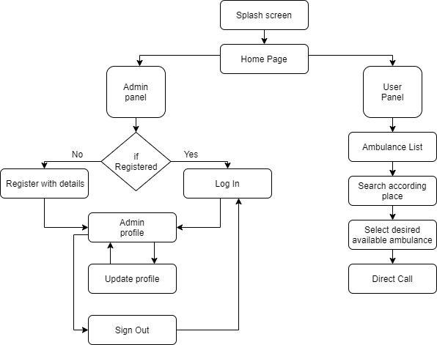

Figure 1: Flow chart of the implementation

**Schema Diagram:**

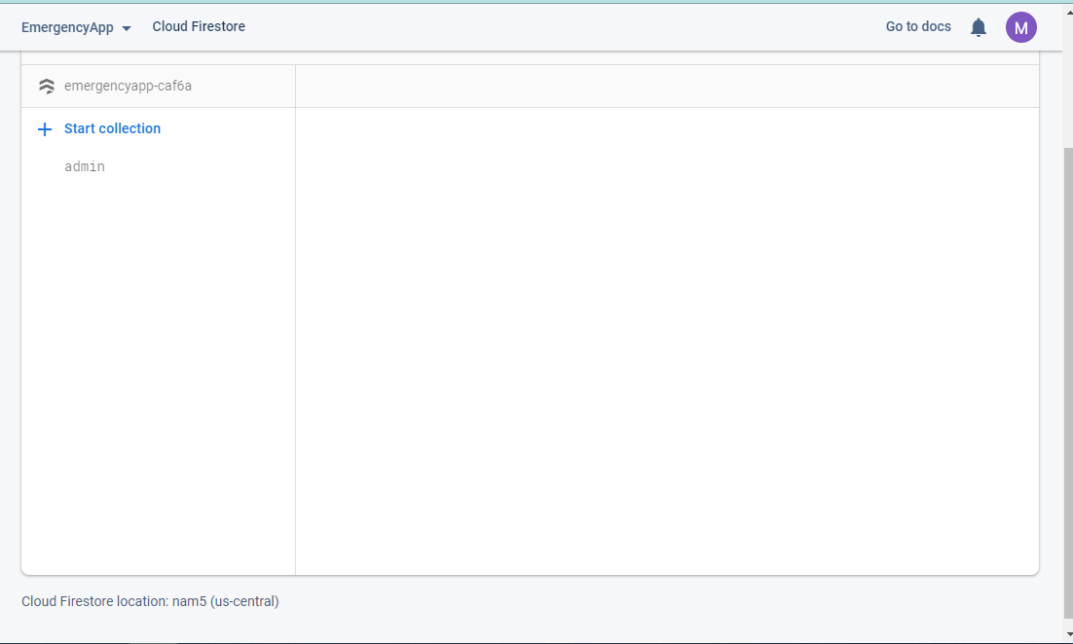 **Figure 2: Firebase cloud Firestore collection- ‘admin’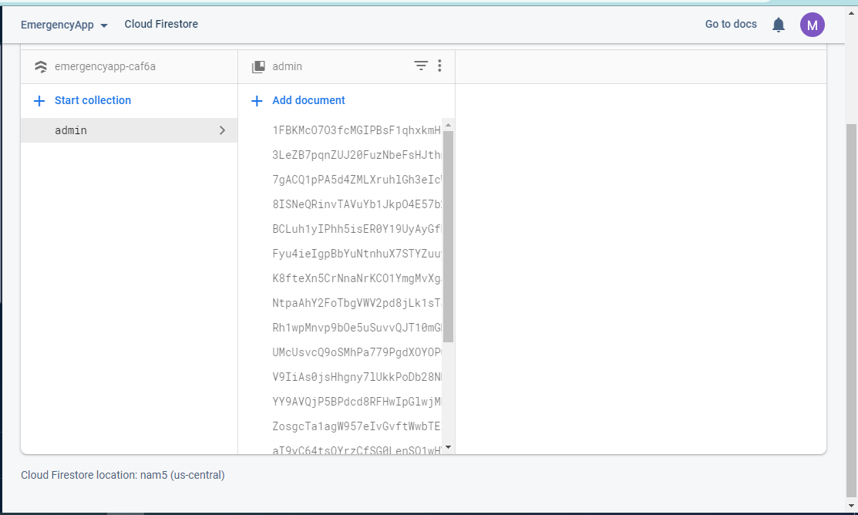Figure 3: Documents under admin class where each document holds each admin’s registration information. Each document has an unique id.**

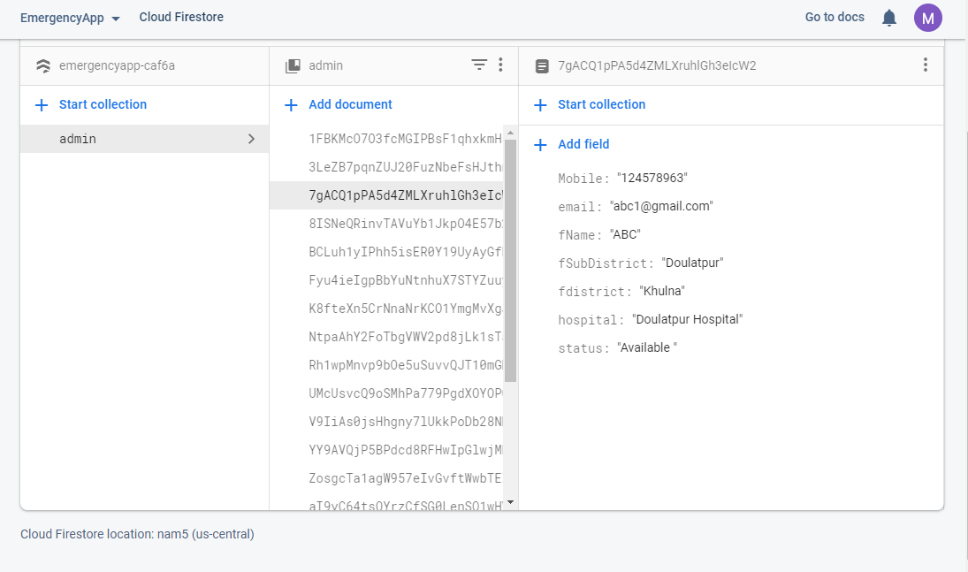

**Figure 4: Fields under a document (Mobile, email, fName, fSubdistrict, fistrict, hospital, status)**

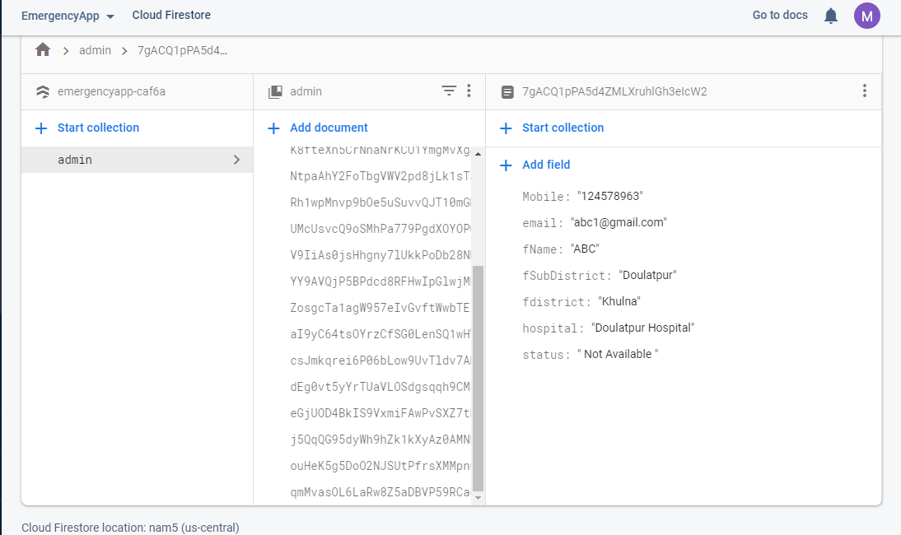

**Figure 5: Fields after updating from admin profile (The field- ‘status’ was updated)**

**Detailed Visualization:**

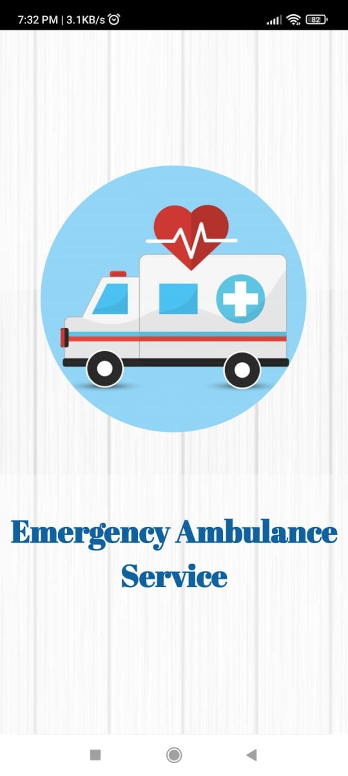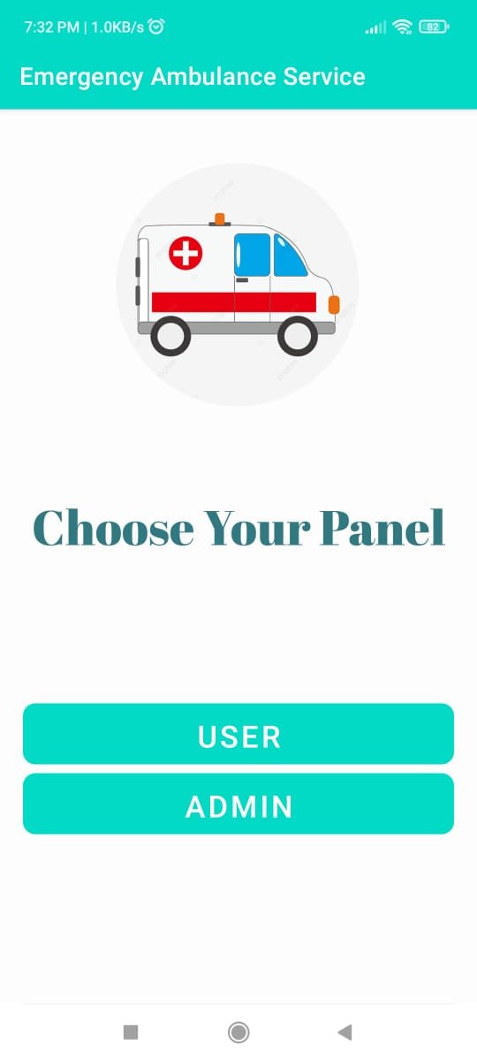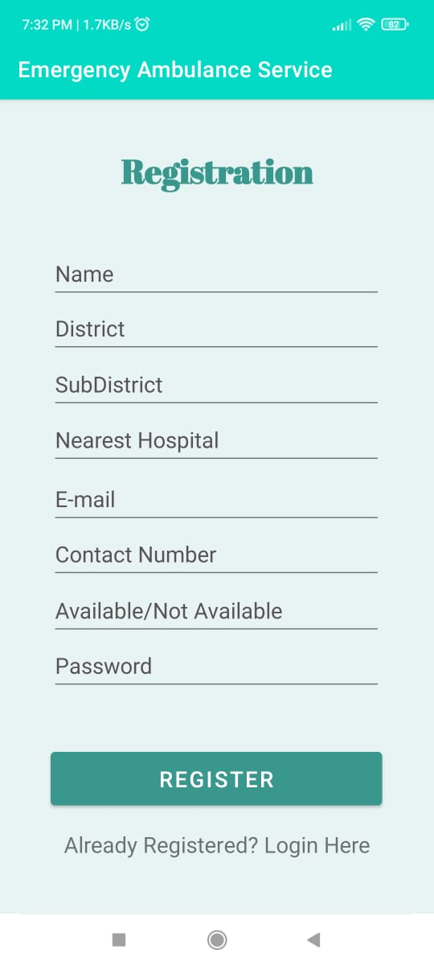

**Figure 6: Splash screen. Figure 7: Home page. Figure 8: Admin Registration page**

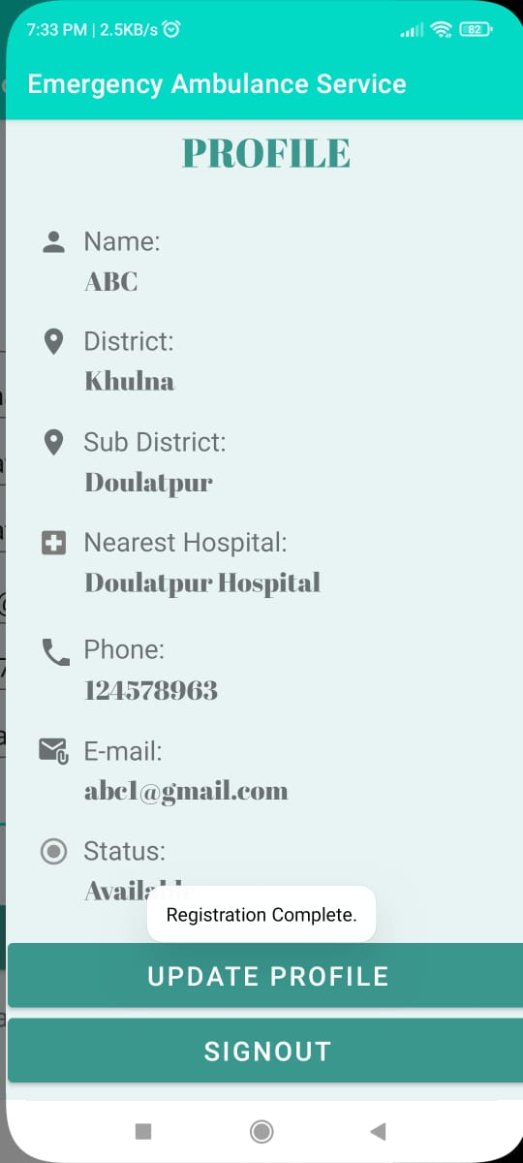

**Figure 9: Admin’s profile after registration completed.**

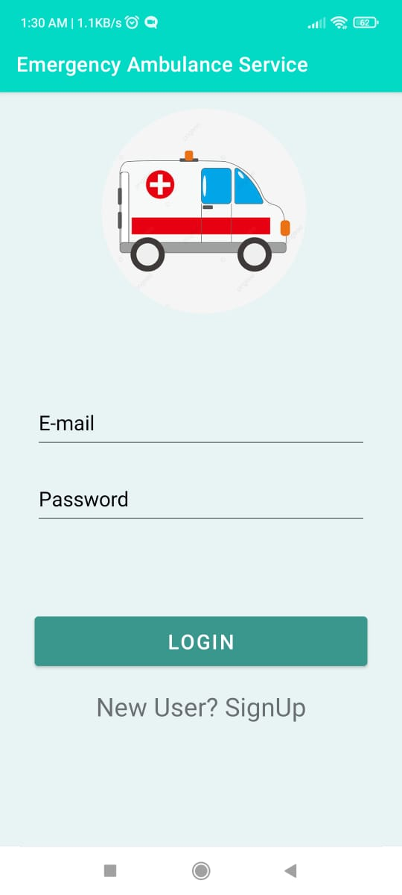

**Figure 10: Login if already registered and go to the profile directly.**

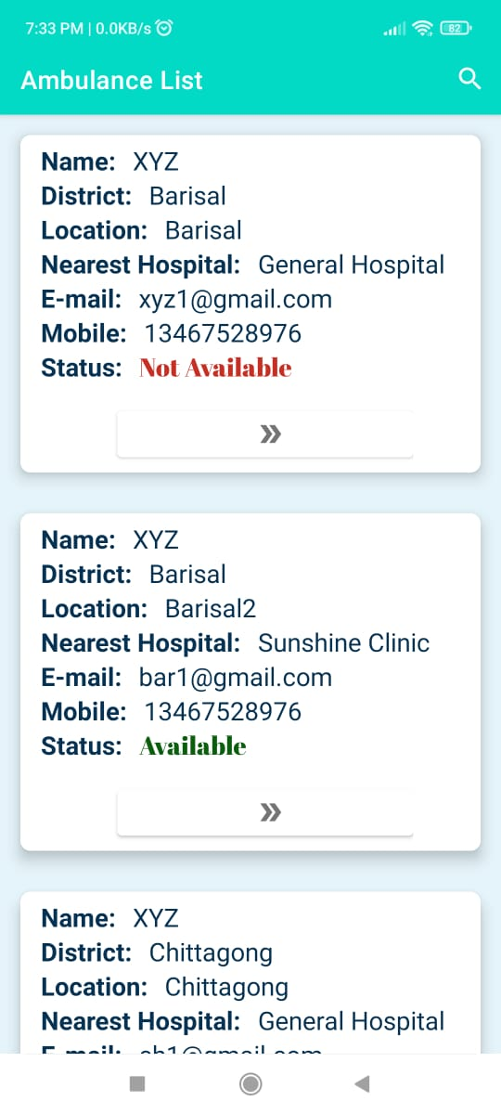

**Figure 11: User page with all ambulance list registered by the admins**

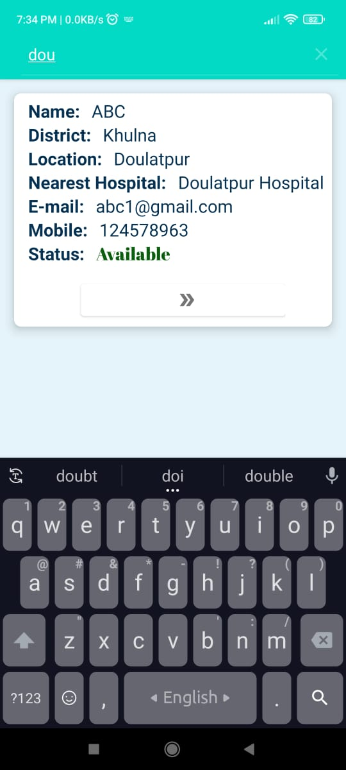

**Figure 12: Search Ambulance by district or sub district.**

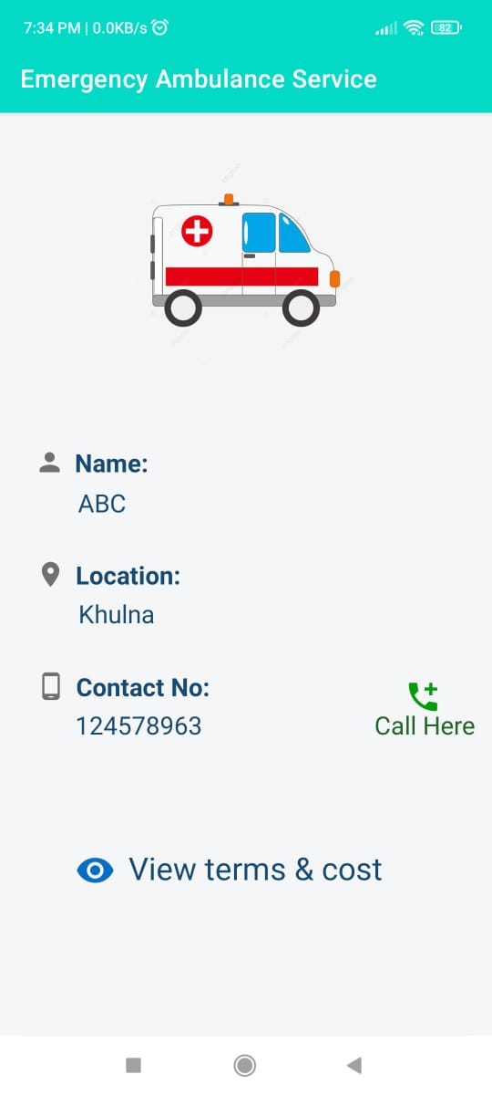

**Figure 13: Calling page**

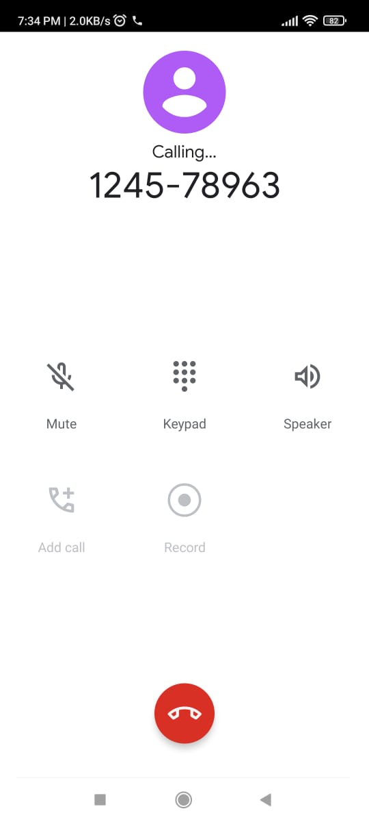

**Figure 14: Calling through the app**

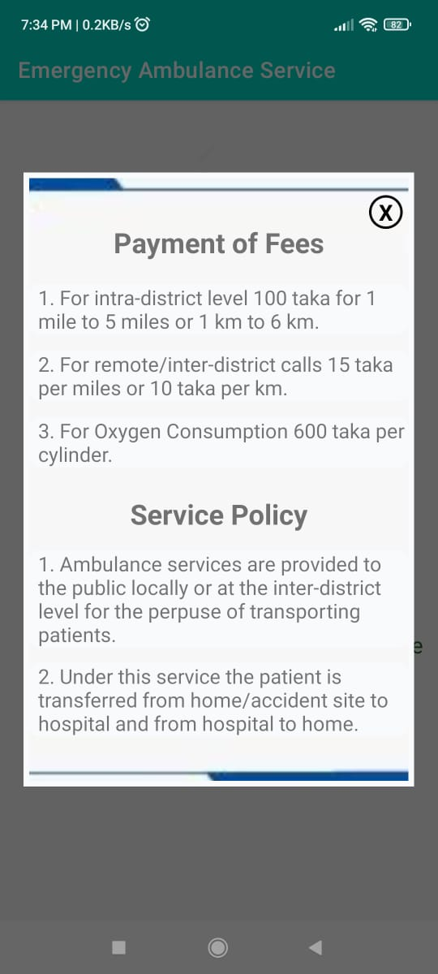

**Figure 15: Payment of fees and service policy in popup window (after pressing the text “View terms & Cost”)**

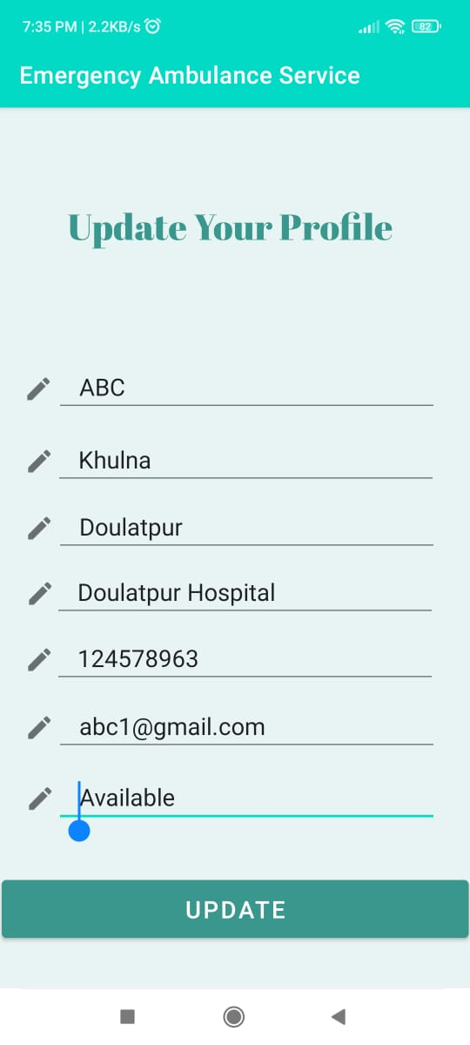

**Figure 16: Edit Admin’s profile and update**

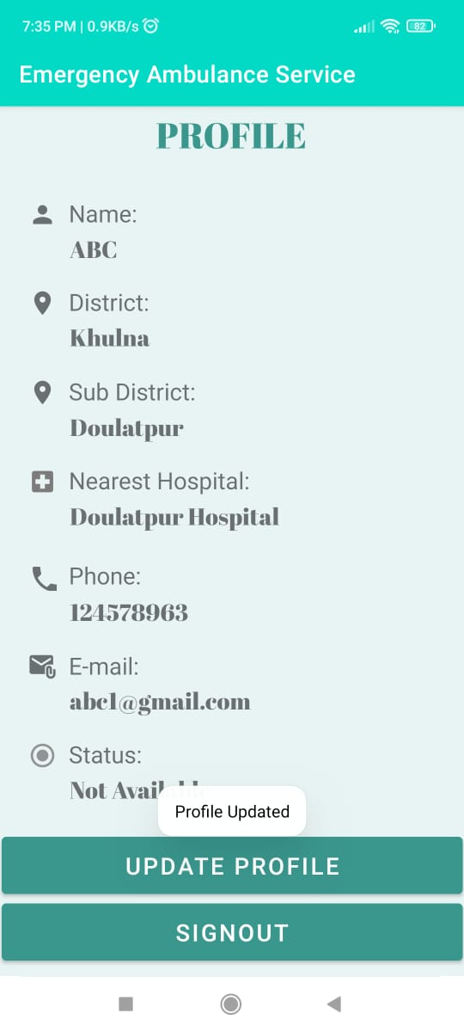

**Figure 17: Profile after update**

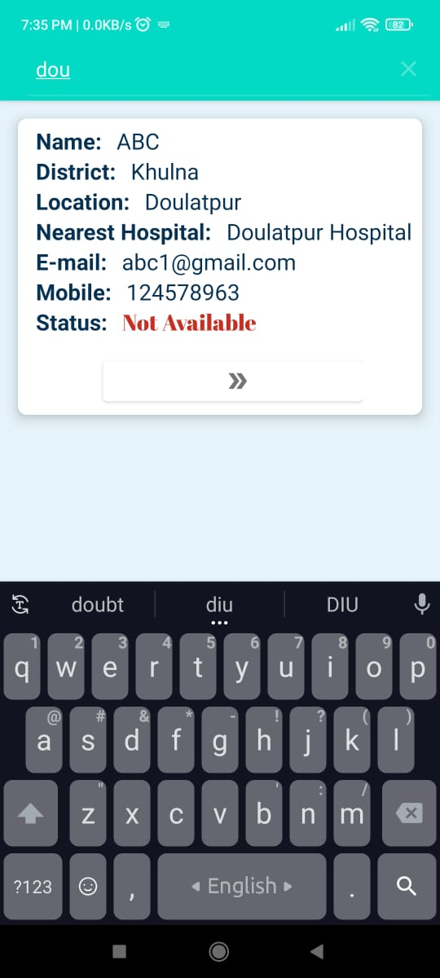

**Figure 18: Changes in user page after update in admin’s profile (Status is changed to “Not Available” from “Available”)**

# Target vs Actual Accomplishment:

My desire was to build a user friendly platform where people can get help in time of emergence. For establishing the app I had set some targets to reach them. Despite some flaws most of the targets were achieved.

I wanted a user page which contains all the list of ambulances registered by the admins through this app. The users are to search according to location. I set the search method based on their district/sub district so that user can search and find his requisite help easily. I wanted to ensure that they can directly select an ambulance and call the owner instantly through the app. The admin would modify their profile details when necessary and the changes would be shown in the user page as well. All these targets were achieved successfully.

But there are some features I wanted to add to the app. I wanted to add map so that the driver can track where exactly he is to go. Now the user has to confirm his location through the call. If the map was added the driver could find the location more easily. I would try to develop this facility to my app very soon.

Despite these, other targets were accomplished successfully and I really hope this app will be very beneficial to people.

# Risk and issues:

Since all the information is stored in database so this app required internet connection for registration purpose and also while updating the profile of admin. User can still use the app and call through it even without internet connection. But if the admin’s profile is updated it won’t be visible at the user page. So for getting the latest update the users also required continuous internet connection.

There’s no privacy issue for the users since they don’t need to give any personal information to get into the app. The admin panel has to register with some information but the security system of cloud firestore is quite good, so there shouldn’t be any risk or issues.

# Discussion and Conclusion:

Emergency Ambulance Service is an app to help people in case of emergency and rescue situation, to give immediate support/service to the patient and to provide proper possible care during transferring the patient to the hospital. This app provides all over emergency ambulance service available in Bangladesh. Service will be provides within 30 minutes and the cost will be minimum. Since this is our first ever android project we had to learn different things about android studio, working procedure etc. Some problems had been faced during developing this app. There were some issues while Dexing the files, therefor Gradle build was failing repeatedly. Then the minimum SDK was changed from 16 to 21 in Gradle build and thus the problem was solved. Also there were some problems while adding the calling feature. Firstly it was planned to add this feature directly in recycler view adapter class. But the permission- ‘CALL_PHONE’ couldn’t be set properly since it was a java class but not an activity. By moving to another new activity through a button the permission getting issue was solved. Despite all these difficulties the project was completed and the Application ran successfully. The teachers helped us relentlessly with their support, inspiration and necessary information related to this project. Above all I am very grateful to Almighty for completing this project successfully.

# Reference:

1. <https://console.firebase.google.com/>
2. <https://firebase.google.com/docs/firestore>
3. <https://firebase.google.com/docs/firestore/data-model>
4. <https://www.youtube.com/watch?v=Mne2SrtySME&list=WL&index=6&t=2s>
5. <https://www.youtube.com/watch?v=Az-dhhEQXA8&list=WL&index=12>